Individual Project Report

Title: Seed Management Application

1

Abstract

Increasing use of data communications over hard papers is leading to widespread application software development. At the same time, the proliferation of technologies has consolidated the major market, making a wholesale migration to per-sonal internet services unlikely in the near future.

This report describes the design, implementation and evaluation of seed management for application control. Several specific solutions al-ready exist for maintain seed management data. However, commercial opportunities for these applications are growing rapidly.

The project developed in this project addresses these problems by creating interface to maintain data online instead of hard papers. The applications developed during the project to evaluate the effective use of these services.

2

Acknowledgements

This project has taken a considerable amount of time and resources and I would like to acknowledge the help of all of those who have made the project possible. In particular I would like to thank my supervisor for his time, patience and guidance, and also for allowing the idea to be pursued originally.

Further to these people I would like to thank the members of the Com-puter Support Group for their technical help in setting up various machines and telephone lines.

Contents

Abstract

Acknowledgment

Contents

1. Introduction
2. Project Schedule
3. Implementation
4. Evaluations
5. Conclusion

* Introduction

This document is a report for the individual project Implementation of a Gen-eralised API for Application Control by Telephony Devices . The project is an attempt to design and create an API (Application Program Interface) for applications so that they can be used by numerous di erent telephony services without speci c knowledge of the capabilities of these devices by the applica-tion.

For the developer of a new application it gives a potentially greatly increased user base, whilst not creating too high an additional coding burden. A new application can also bene t from the advantage of non-recurring engineering allowing greater sophistication. This project also explores the possibility that a user may wish to control an application from multiple locations regardless of the device that they have access to at that point in time - the fact that the user should not be limited to the case where they are physically in front of a computer hosting the software.

1.1 Aims & Objectives of the Project

The aim of this project is to create an web application control by admin, and to produce a number of example applications and separate device implementations. In other words the goal of this project is to abstract the input and output interfaces of an application to the extent that new access devices can be added to a system without any changes being necessary for the application. Thus applications do not need to be rewritten to cope with each technological advance, and devices only need to be added into this system once to gain from immediate access to all available applications.

A number of example applications will also need to be created in order to eval-uate the implementation. An example application would be to move a cursor around a screen, or to control a character in a game, from these devices. Ap-plication output should be provided to the user appropriately dependent on the access device used. With this project in operation, a user should be able to access all of the features of an application by telephone, rather than by having to sit at a terminal and use a keyboard and mouse.

1.2 Overview of the Project Progress

A formal view to the progress of the project was taken and resulted in a sys-tematic development of the required components. In order to meet the stated aims, the following steps were undertaken :

1. Initial Design - The project, which were designed independently:
   1. Design of the Project - Consideration of issues such as the services re-quired, the semantics of the needed operations and the language and systems to be used.
2. Speci cation - The interfaces between the four areas were speci ed pre-cisely, and the requirements for each of the four sections were elicited.
3. Implementation - These four areas were separately implemented, mostly in .Net,. Wherever possible existing systems were used to provide the basis of the functionality.
4. Testing - The implementation from each of the four parts were then tested as a single system
5. Evaluation - The system was evaluated through comparisons to existing systems were possible and through qualitative analysis of the commercial viability of the implementation.

On completion of the project this report was produced to document the decisions made in the above steps and to comply with the required regulations for a project report in the Department of Computing at Imperial College[2].

1.3 Overview of this Report

This report fully describes the project undertaken. However in order to control the length of the report, the reader is on occasion referred to a bibliographical reference if particular details are required in an area.

The report is split into ve main sections :

1. Introduction - This gives an introduction to the project, its aims, an overview of the work undertaken in the project and an overview of this report.
2. Background Research - Analysis of current projects available in this area and an attempt to de ne what is the state of the art . It also contains

8

analysis of the design issues for implementation of a possible solution to the problems raised, and a discussion of the technologies behind each of the proposed access device methods. Further, possible extensions to the basic design requirements are proposed.

1. Implementation - Discussion of the implementation choices taken and the software that was developed. Detailed reports are given for the implemen-tation and the implementation of the daemon which manages connections from users along with a sample application.
2. Evaluation - Evaluation of the success of the implementation in meeting the needs discovered in the background research is given in quantitative and qualitative terms. The system is compared to other available prod-ucts.
3. Conclusions - Analysis of the successes and failures of the project, and discussion of the advances made. A discussion of the commercial viability of the implementation is also given. Possible extensions and further work that could be undertaken are then discussed.
4. Background Research

The project came about in response to the need to allow access to information and control systems from remote or mobile locations using everyday equipment. However, enabling this on a case by case basis for an application is di cult, time consuming and does not enable future devices to be used without changing the application. This background examines the steps taken to design by looking at the various components of the system, and gives references for further reading on the technologies used. This section tries to consider the current state of the art in this area by looking at currently available products and tools. From this the shortcomings of these products can be analysed, giving a base for the production of a new generalised API.

The rationale behind the project is that if a simple API can be developed as an interface between applications and these devices, then the task of adding each separate device is an operation which only needs to be undertaken once rather than on a per application basis. The simpler and easier that the API is to use from an application standpoint, the more likely it is that application developers will be prepared to support the API. Likewise another design goal is that the ability to add new devices is as simple as possible.

Overall then the project splits into :

1. The theoretical design of the API architecture
2. Implementation of this design
3. Implementation of at least one device driver which interfaces with the

API

1. Implementation of at least one example application which interfaces with the API

However before looking at the actual design process, it is important to look at the motivation for the project in a little more depth, and to see which other projects or research in this area have been undertaken.

* Project Schedule
  + 1. Analysis ------------🡪 2 days
    2. Requirement Gathering --------🡪 6 days
    3. Study -------🡪 1 day
    4. Implementation -----------🡪 8 days
    5. Testing & Implementation -------🡪3 days

1. Implementation

The implementation of the project consists of a set of modules , which are used to operate the system. This helps to rempve data redundancy and save the lot of paper by doing management online. And can check real time data at anywhere and at any time.

Screenshots

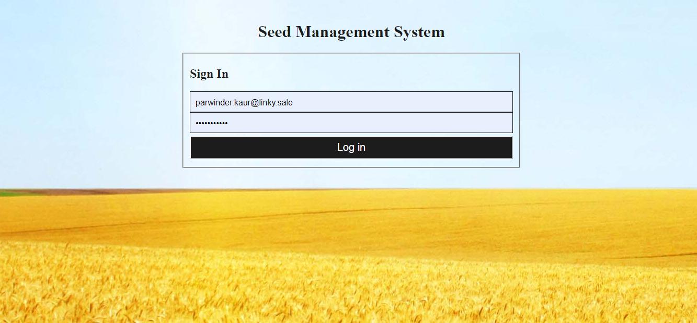.

This is login screen for Seed management system. This can be login by different roles in the system.

2. This screen is the landing page while login into the system.

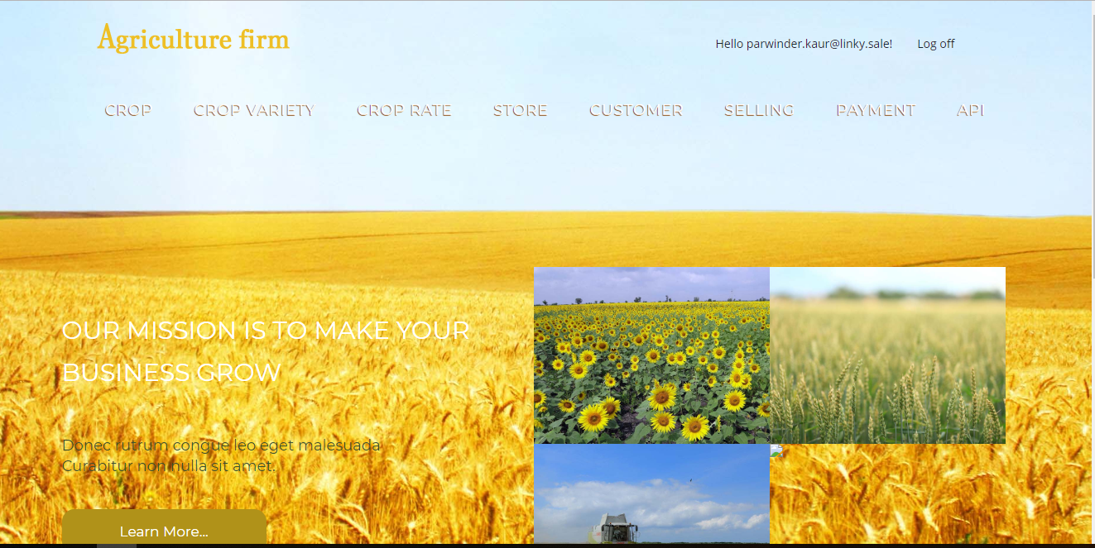

1. This screenshot is to maintain details of crops.

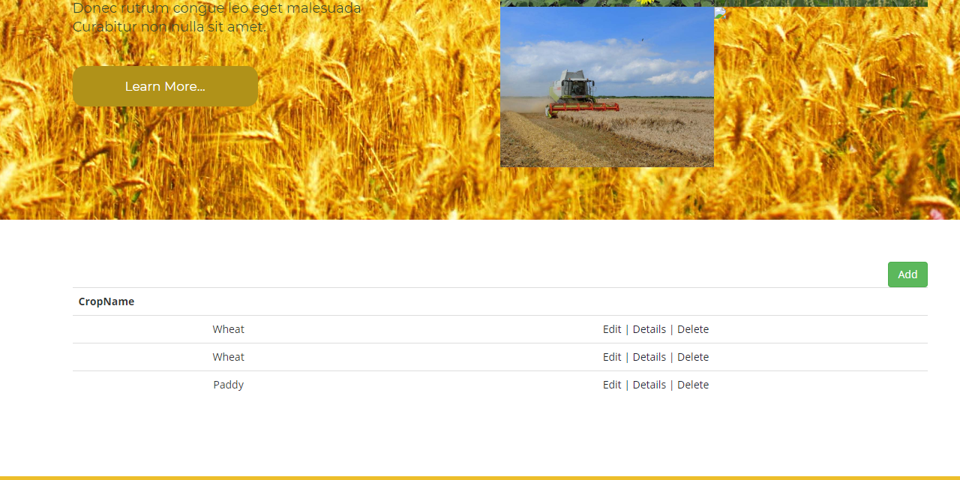

1. Crop Screen

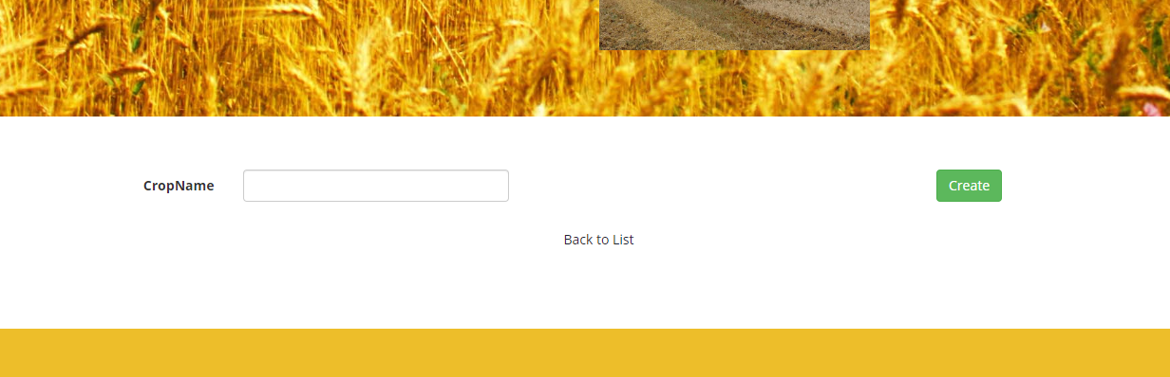

1. Crop Variety Screen

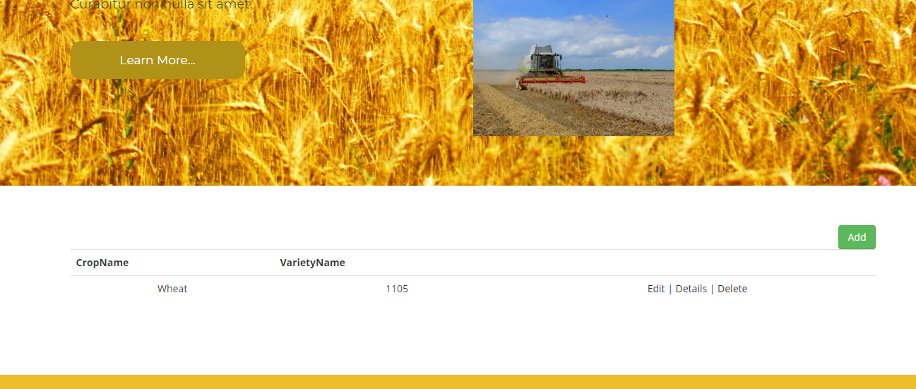

1. Create Crop Variety

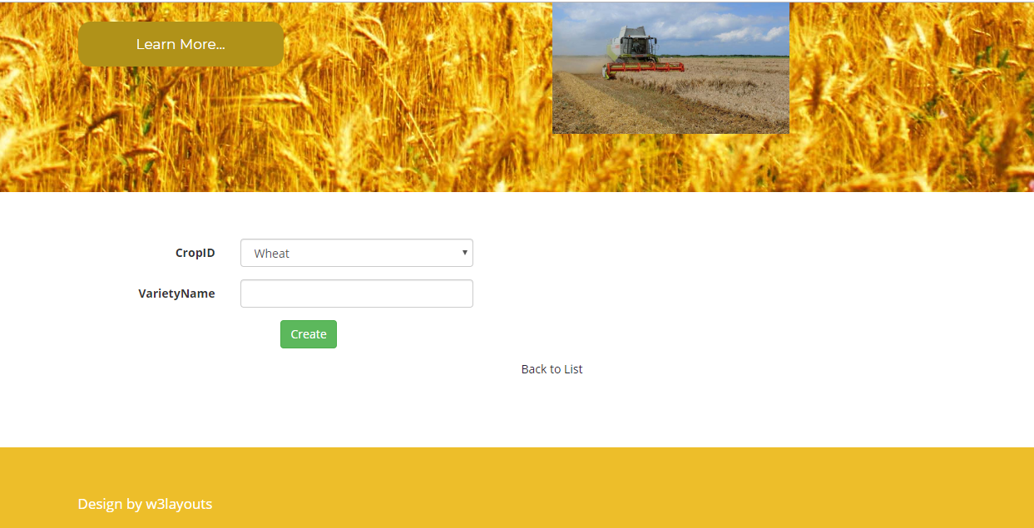

1. Crop Rate List Screen

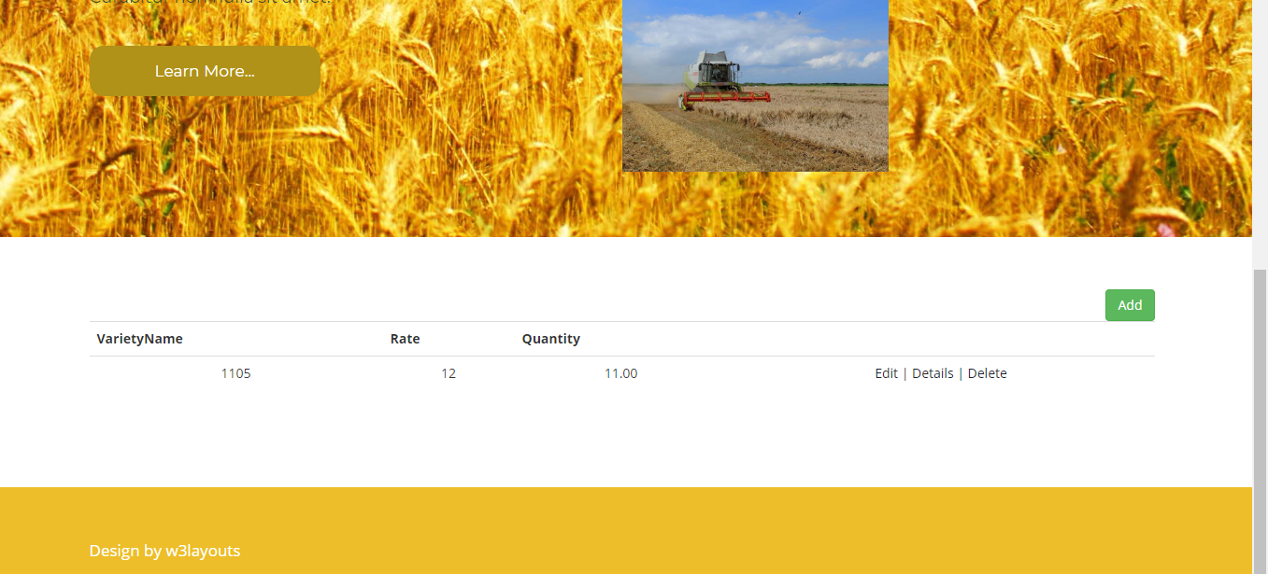

8. Edit Crop Rate

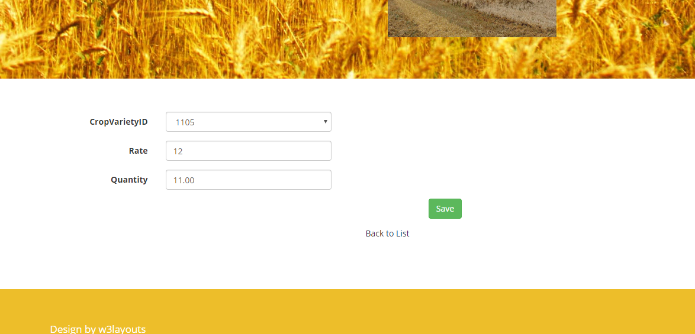

9. Store List

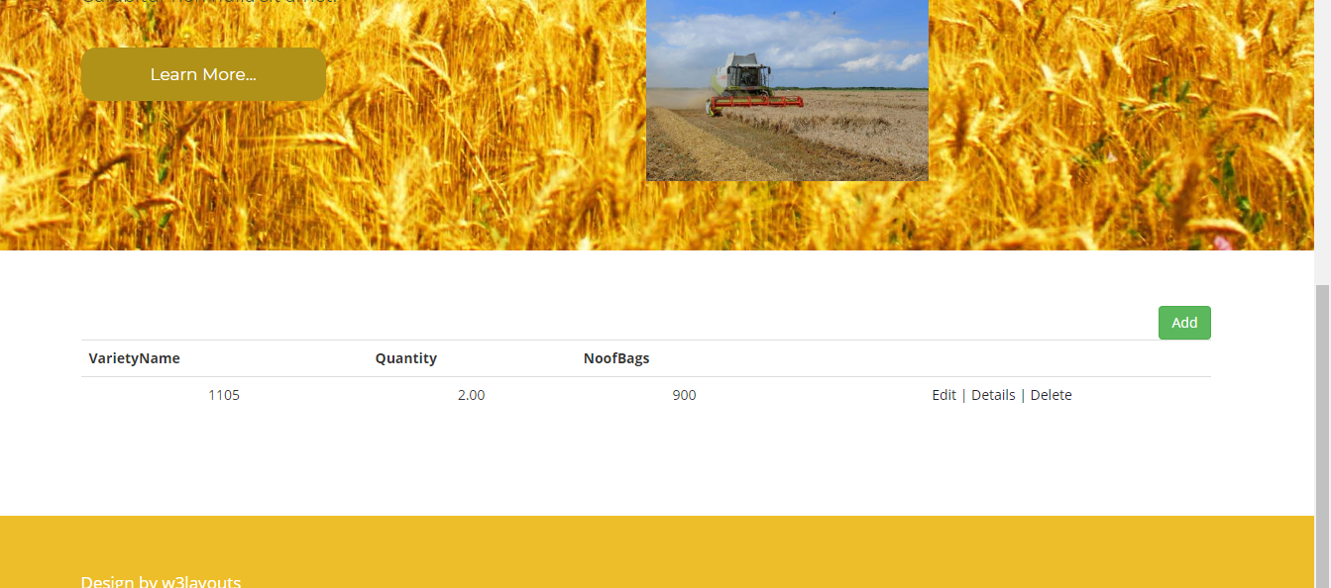

10. Create Store List

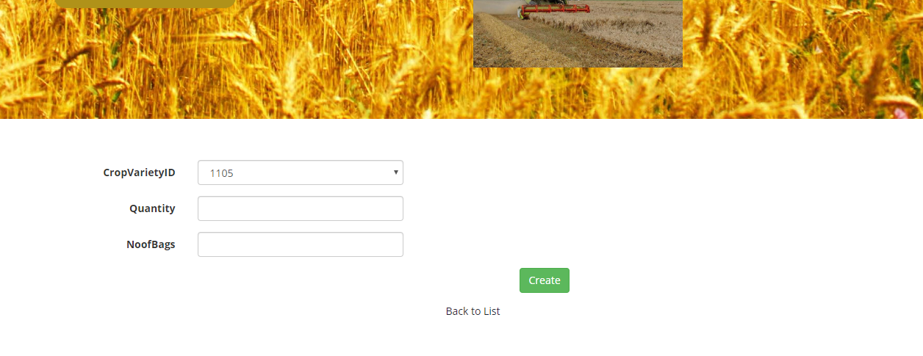

11. Customer List

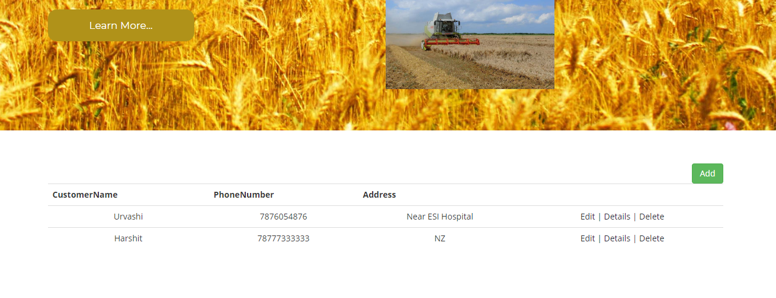

12. Edit Customer

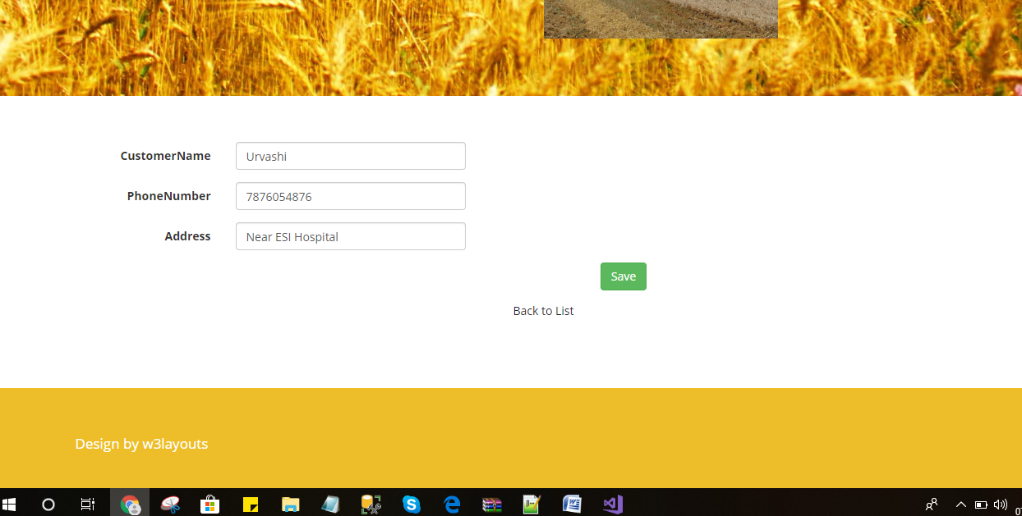

13. Seed Selling List

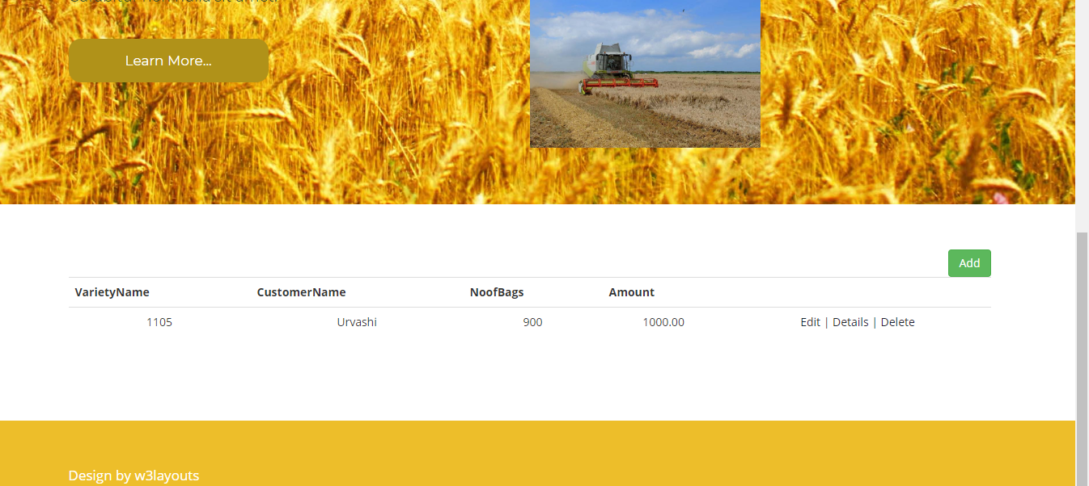

14. Create Seed Selling Record Screen

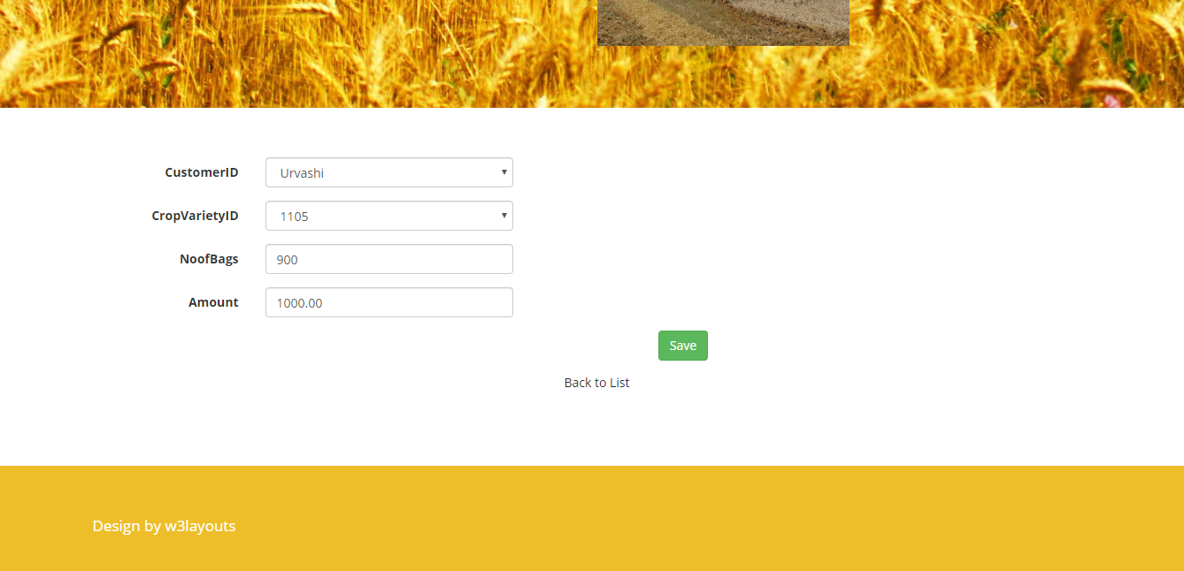

15. Bank Payment List

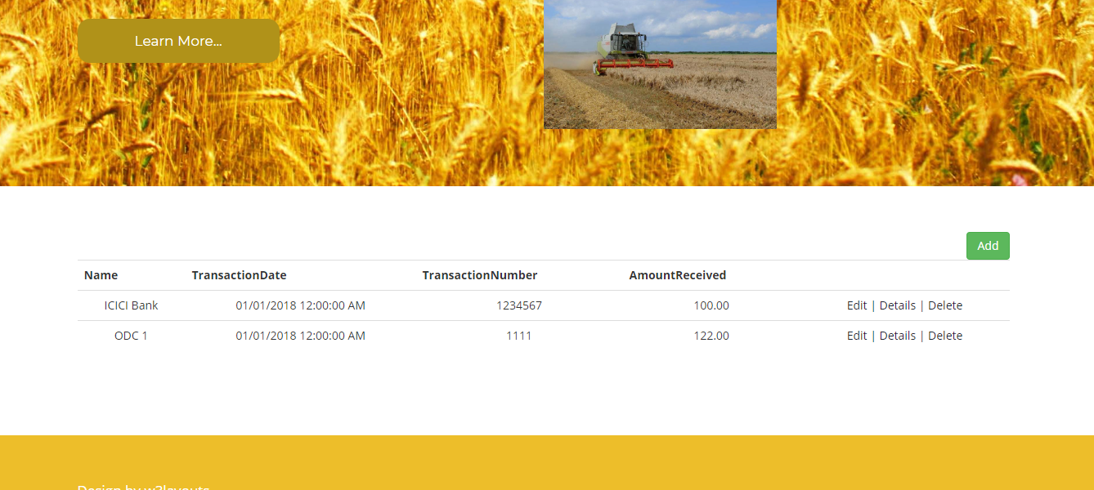

18. Bank Payment Create Screen

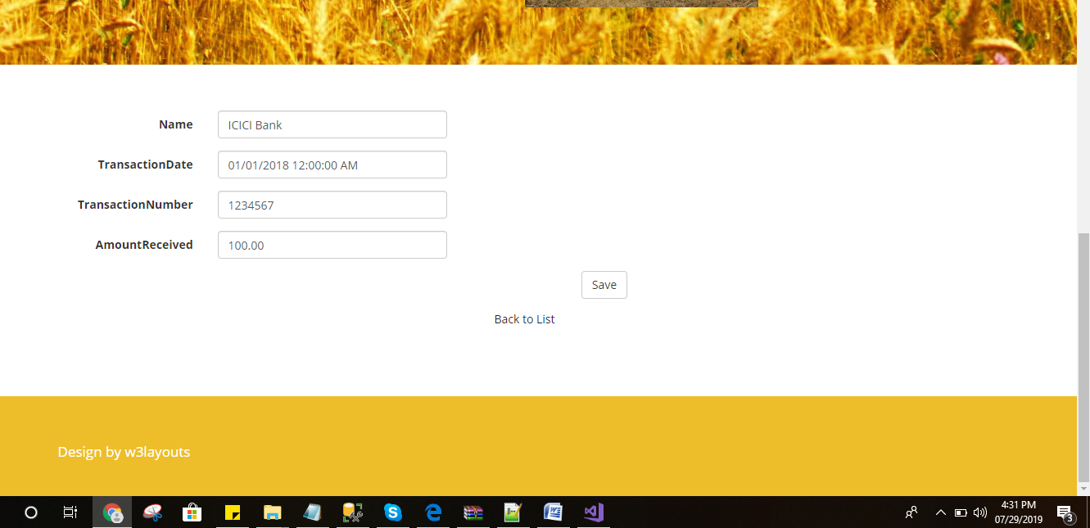

* Conclusions

This section summarises the overall conclusions drawn from this project and discusses the possible commercial viability of the implementation produced. It also describes how the project could be extended with further work. The key conclusions that can be made are :

A generalised use for application control by telephony devices has been implemented and evaluated successfully, despite the highly disparate func-tionality of many of these devices.

Most applications do not need to have knowledge of the exact capabilities of the input and output method in use by the user.

Although access devices such as a telephone have limited input capabilities in comparison with a personal computer, these capabilities are su cient for the control of many applications, especially where visual or audible feedback is available.

There are a considerable number of applications to which users desire access from wherever they nd themselves, and with whichever device they have access to at the time.

The implementation of the API as a dynamically linked library gives greater

It is also worth noting that the availability of open source tools for many tasks enables a considerably higher rate of application development - without the exis-tence of many of the external applications and utilities used, the implementation discussed here would not have been possible.